Benin

## GNI per capita and development level

The data set shows the GNI per capita and development level of the country each year.

## # A tibble: 19 x 5  
## country iso3c date GNIperCapita devCategory   
## <chr> <chr> <dbl> <dbl> <chr>   
## 1 Benin BEN 1996 856. Low Income   
## 2 Benin BEN 1998 899. Low Income   
## 3 Benin BEN 2000 946. Low Income   
## 4 Benin BEN 2002 979. Low Income   
## 5 Benin BEN 2003 982. Low Income   
## 6 Benin BEN 2004 996. Low Income   
## 7 Benin BEN 2005 987. Low Income   
## 8 Benin BEN 2006 995. Low Income   
## 9 Benin BEN 2007 1023. Low Income   
## 10 Benin BEN 2008 1048. Lower Middle Income  
## 11 Benin BEN 2009 1040. Lower Middle Income  
## 12 Benin BEN 2010 1031. Lower Middle Income  
## 13 Benin BEN 2011 1036. Lower Middle Income  
## 14 Benin BEN 2012 1051. Lower Middle Income  
## 15 Benin BEN 2013 1096. Lower Middle Income  
## 16 Benin BEN 2014 1135. Lower Middle Income  
## 17 Benin BEN 2015 1120. Lower Middle Income  
## 18 Benin BEN 2016 1125. Lower Middle Income  
## 19 Benin BEN 2017 1154. Lower Middle Income

## GDP growth and economic growth classification

The data set shows the GDP growth and the ecomic growth classification of the country each year.

## # A tibble: 19 x 5  
## country iso3c date GDPannualGrowthRate GDPgrowthCategory4  
## <chr> <chr> <dbl> <dbl> <fct>   
## 1 Benin BEN 1996 4.32 moderate growth   
## 2 Benin BEN 1998 3.96 moderate growth   
## 3 Benin BEN 2000 5.86 fast growth   
## 4 Benin BEN 2002 4.64 moderate growth   
## 5 Benin BEN 2003 3.44 moderate growth   
## 6 Benin BEN 2004 4.43 moderate growth   
## 7 Benin BEN 2005 1.71 slow growth   
## 8 Benin BEN 2006 3.94 moderate growth   
## 9 Benin BEN 2007 5.99 fast growth   
## 10 Benin BEN 2008 4.90 moderate growth   
## 11 Benin BEN 2009 2.32 slow growth   
## 12 Benin BEN 2010 2.11 slow growth   
## 13 Benin BEN 2011 2.96 moderate growth   
## 14 Benin BEN 2012 4.81 moderate growth   
## 15 Benin BEN 2013 7.19 fast growth   
## 16 Benin BEN 2014 6.36 fast growth   
## 17 Benin BEN 2015 1.78 slow growth   
## 18 Benin BEN 2016 3.34 moderate growth   
## 19 Benin BEN 2017 5.67 fast growth

## Development trend

The plot shows the development trend of the country.

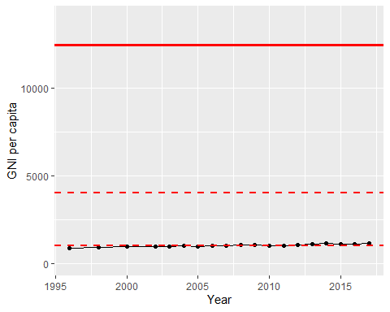

GNI Per Capita Trend